**BARBAR BOOKING SITE**

This barbar booking site helps the customer to book their appointment.Samples of screen shot how the website look.

**HOME PAGE**

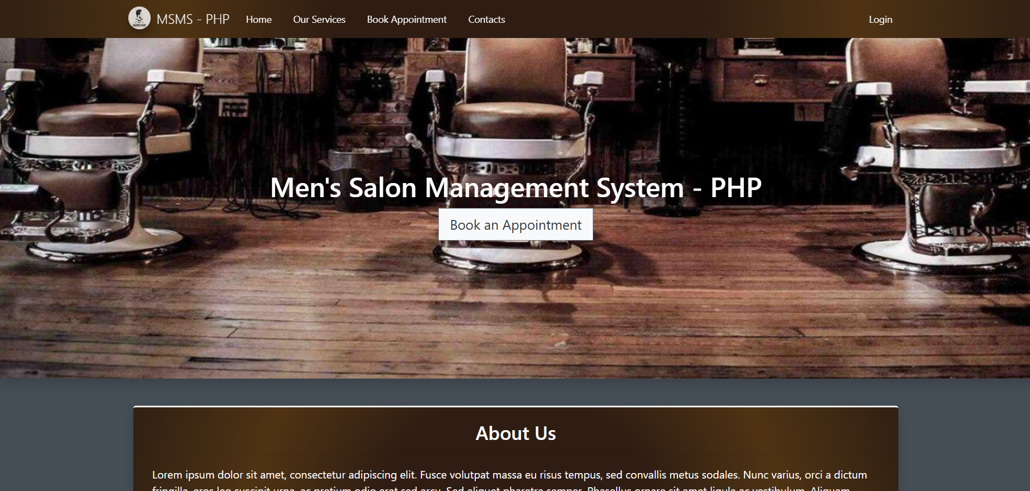

**SERVICE PAGE**

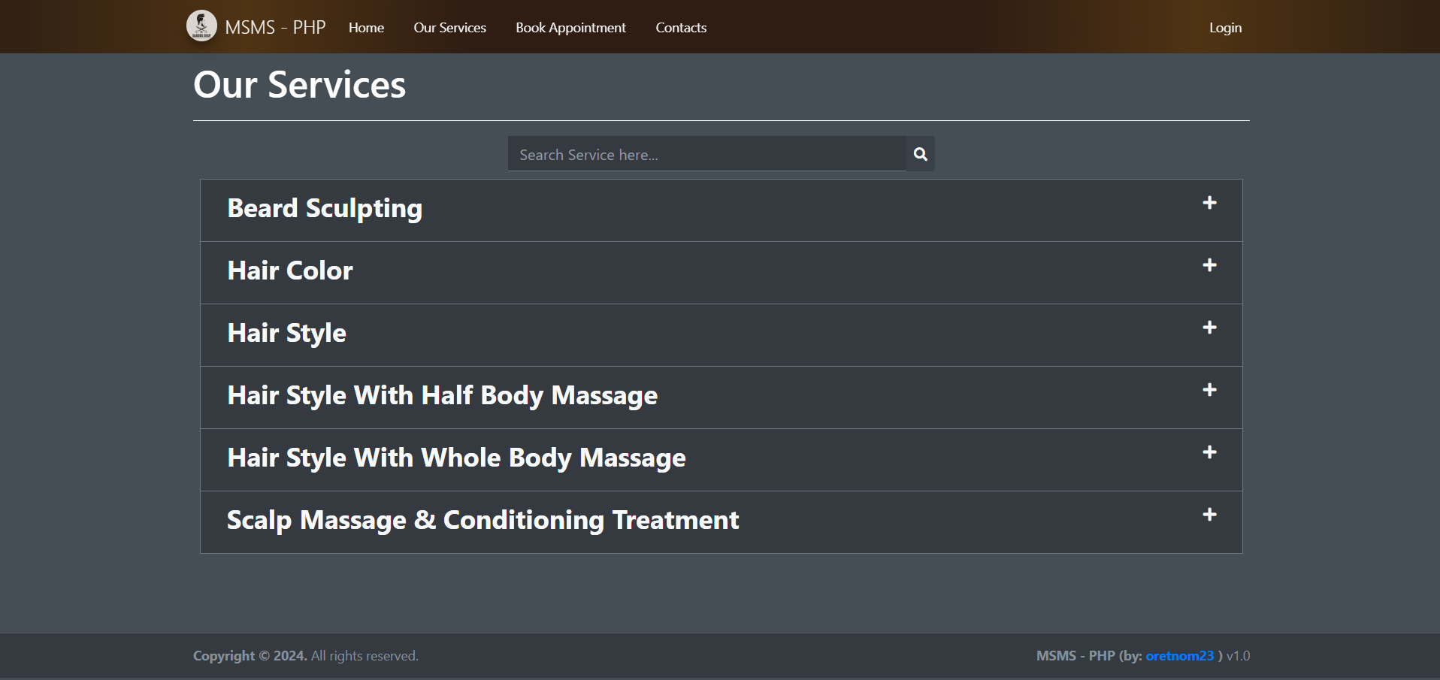

**APPOINMENT BOOKING BY CUSTOMER**

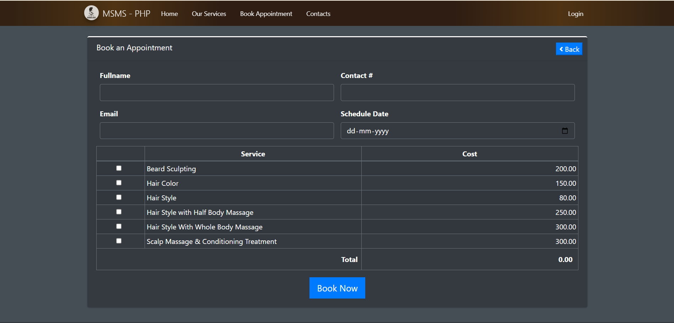

**CONTACT ABOUT THE SHOP**

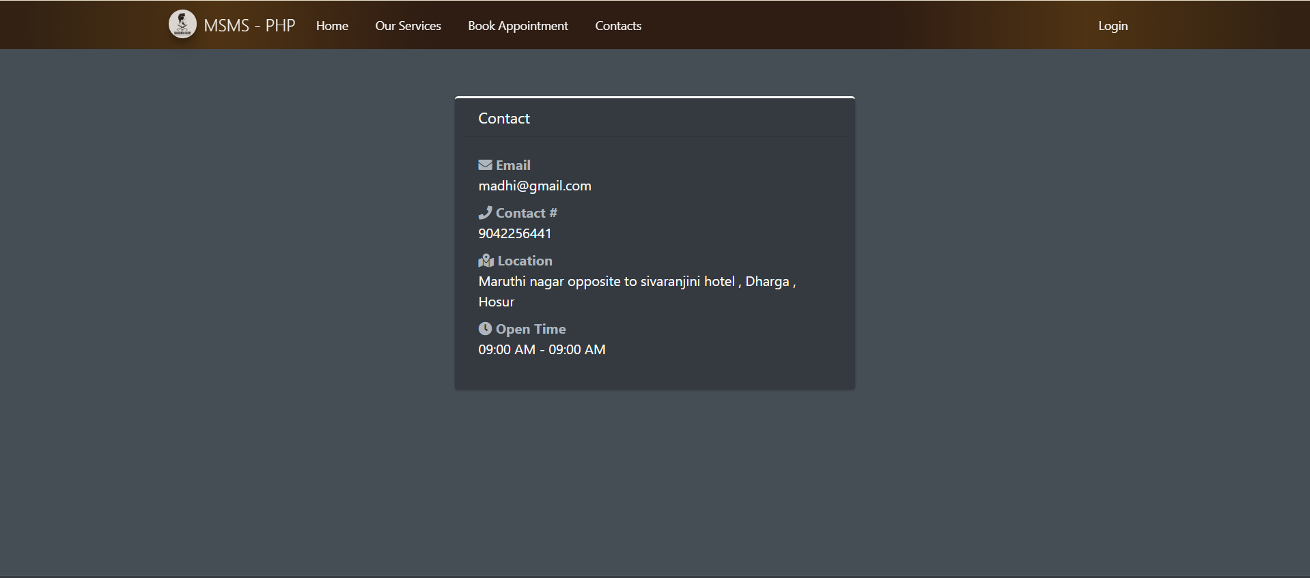

**ADMIN LOGIN**

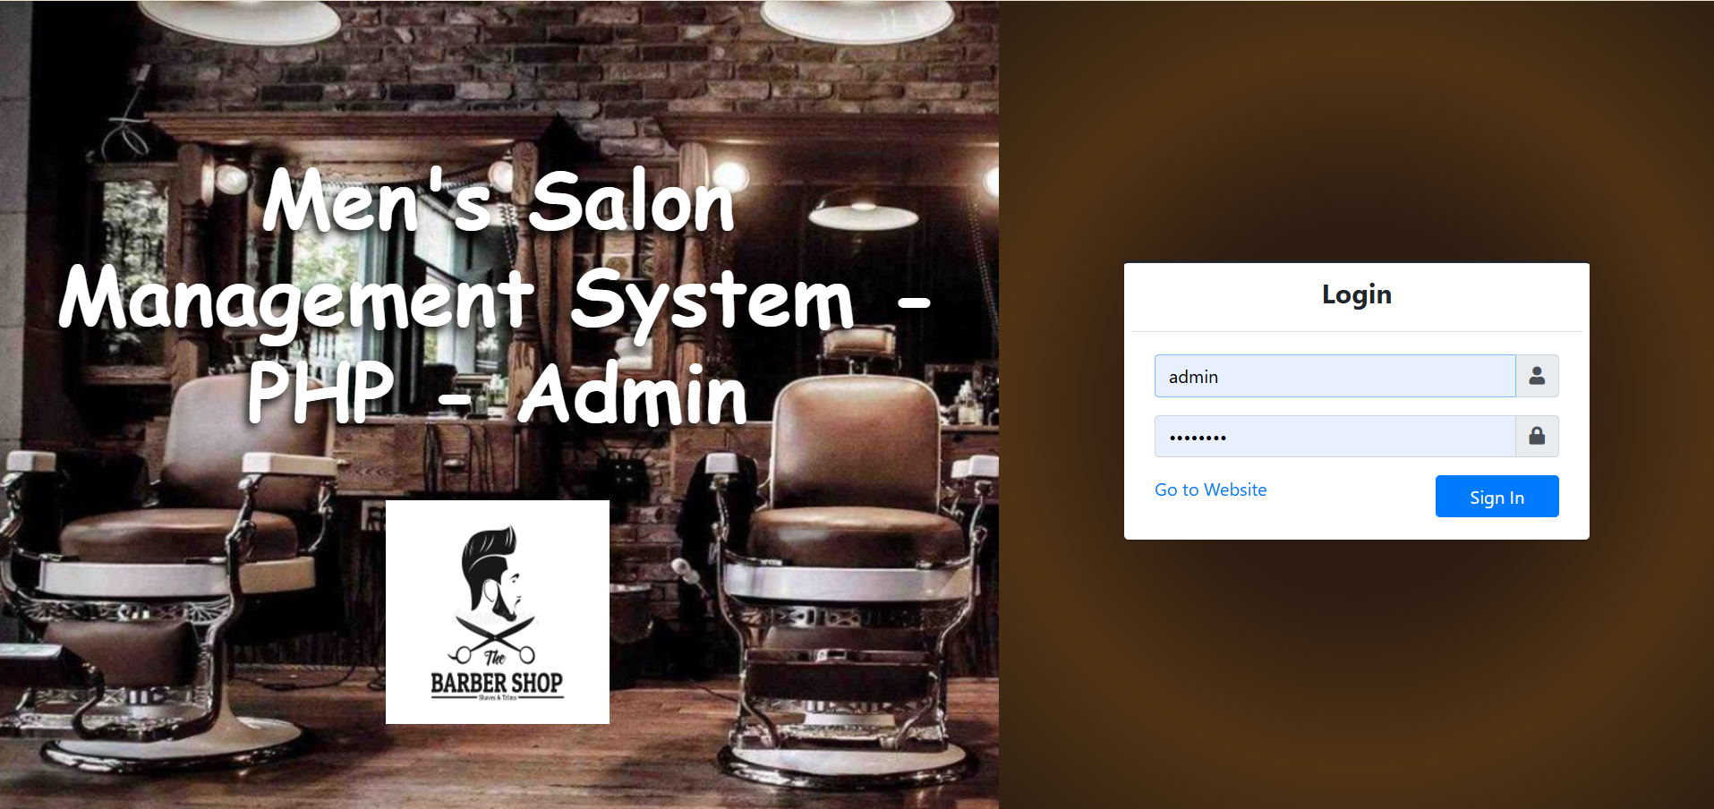

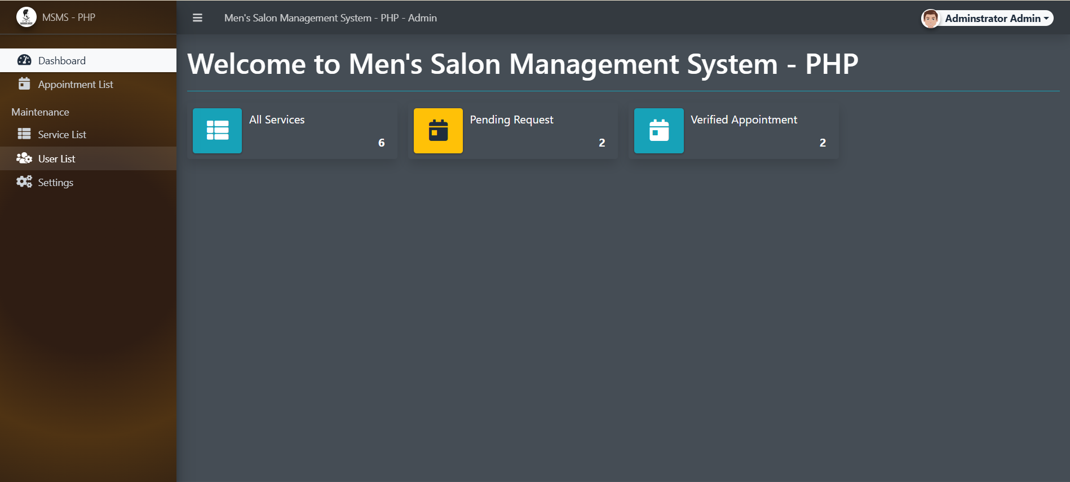

**APPOINMENT LIST**

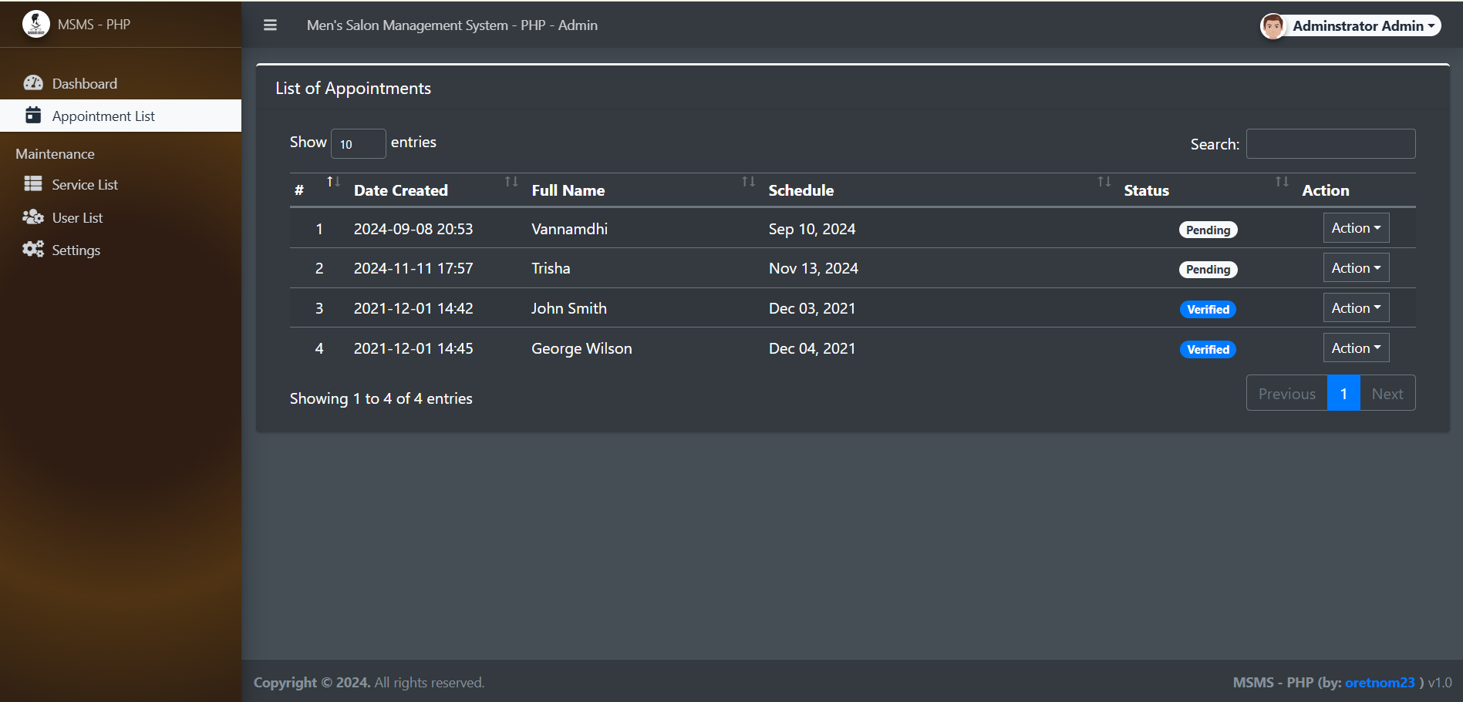

**USER LIST**

